19/12/2023

Chakradhar Bhogapurapu, BIBA

Python

CSV files(Comma Seperated Values)

csv is a module in python that is used to do operations on csv files i.e., read, write, append, etc.

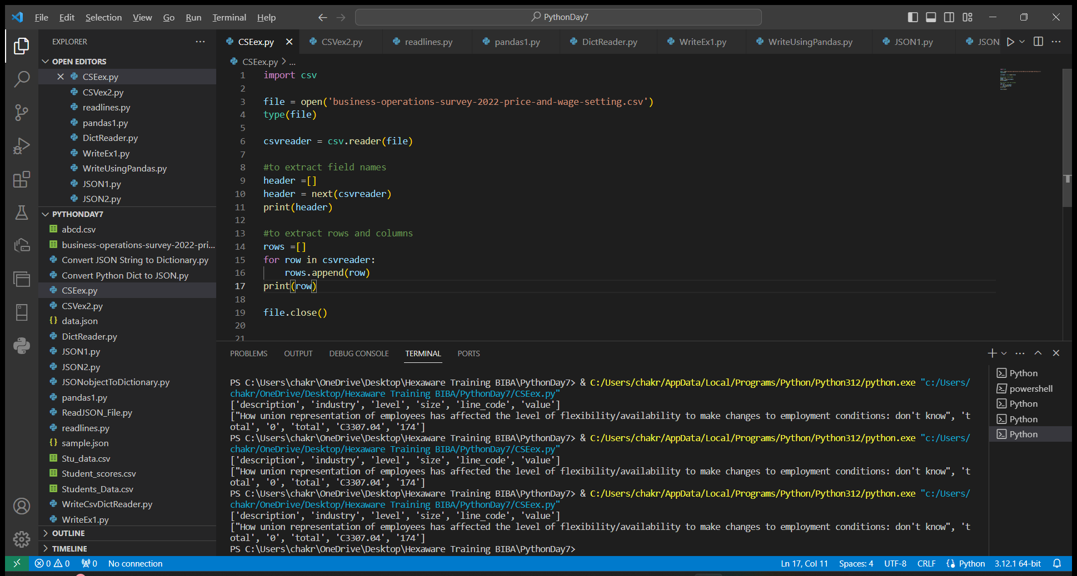

CSV file that stores values in a table format

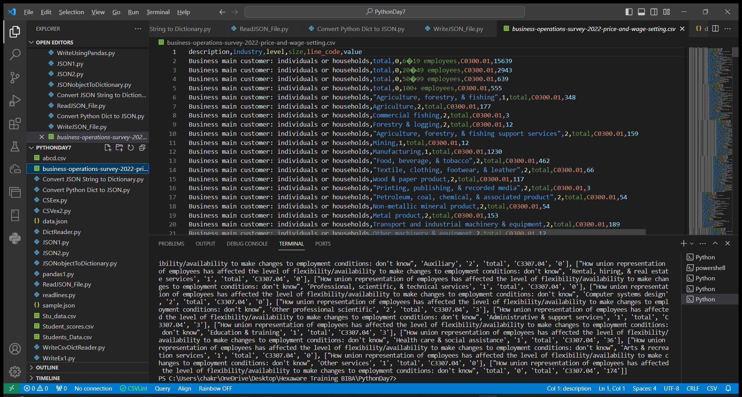

Using with()

There is no need to close the file separately while using with(). We need to open file in read mode.

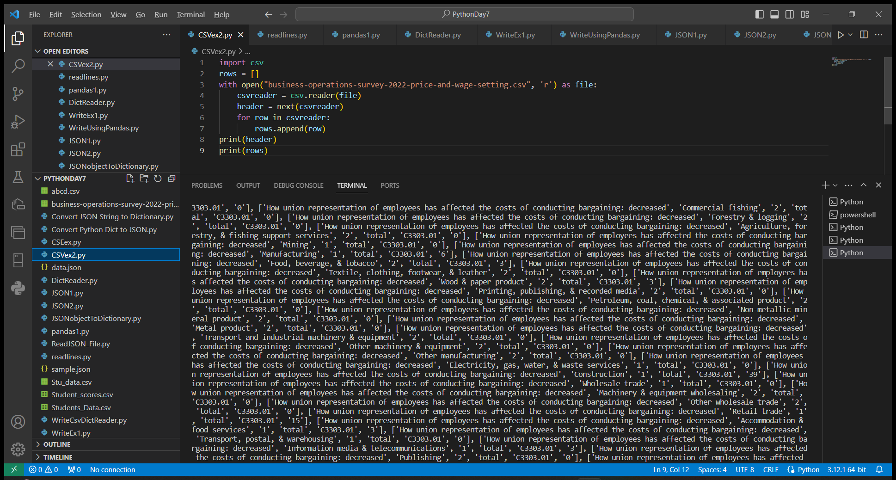

Using with() and .readlines()

.readlines() method is the answer. It returns all the lines in a file as a list. Each item on the list is a row of our CSV file.

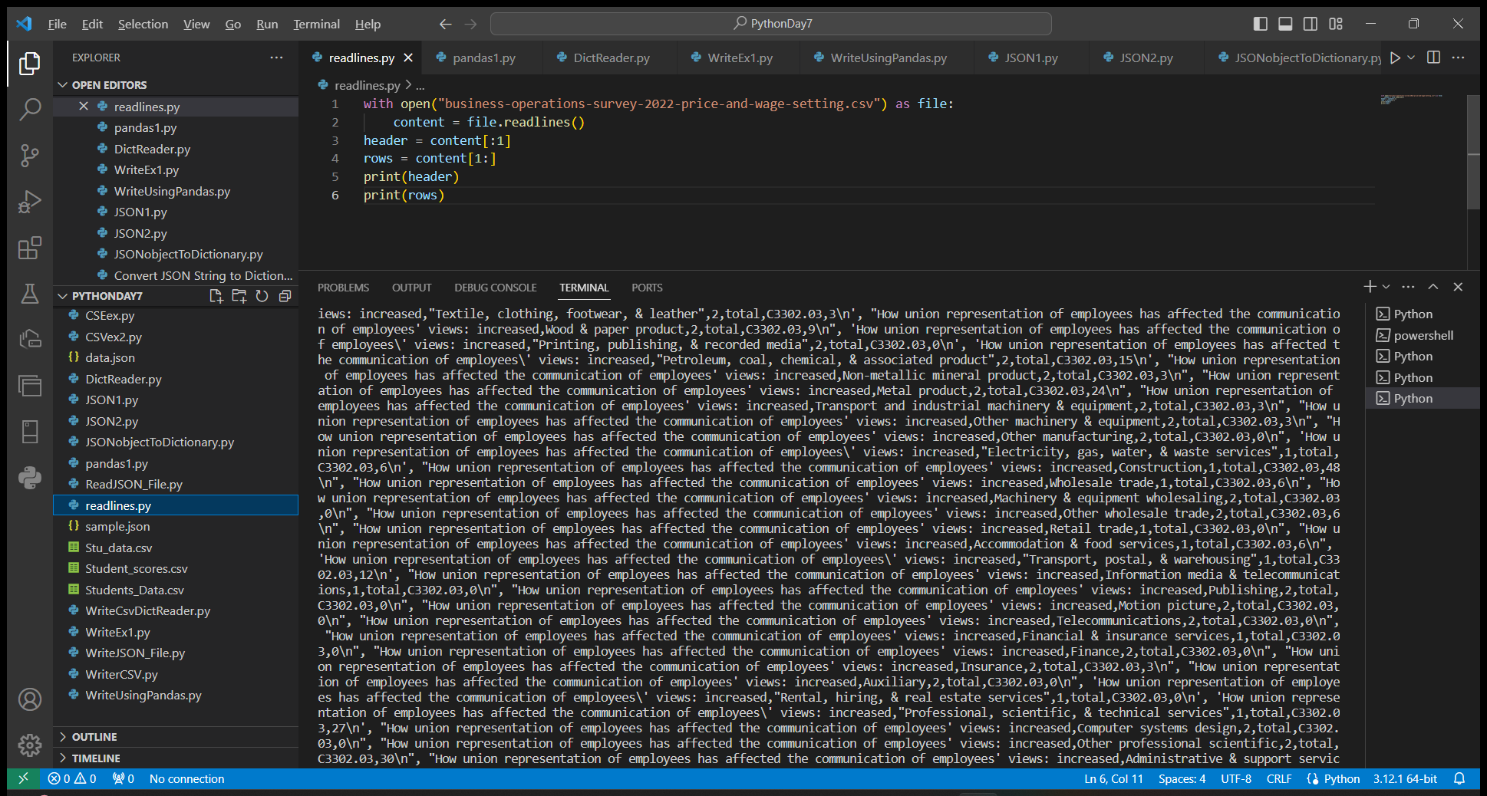

Write()

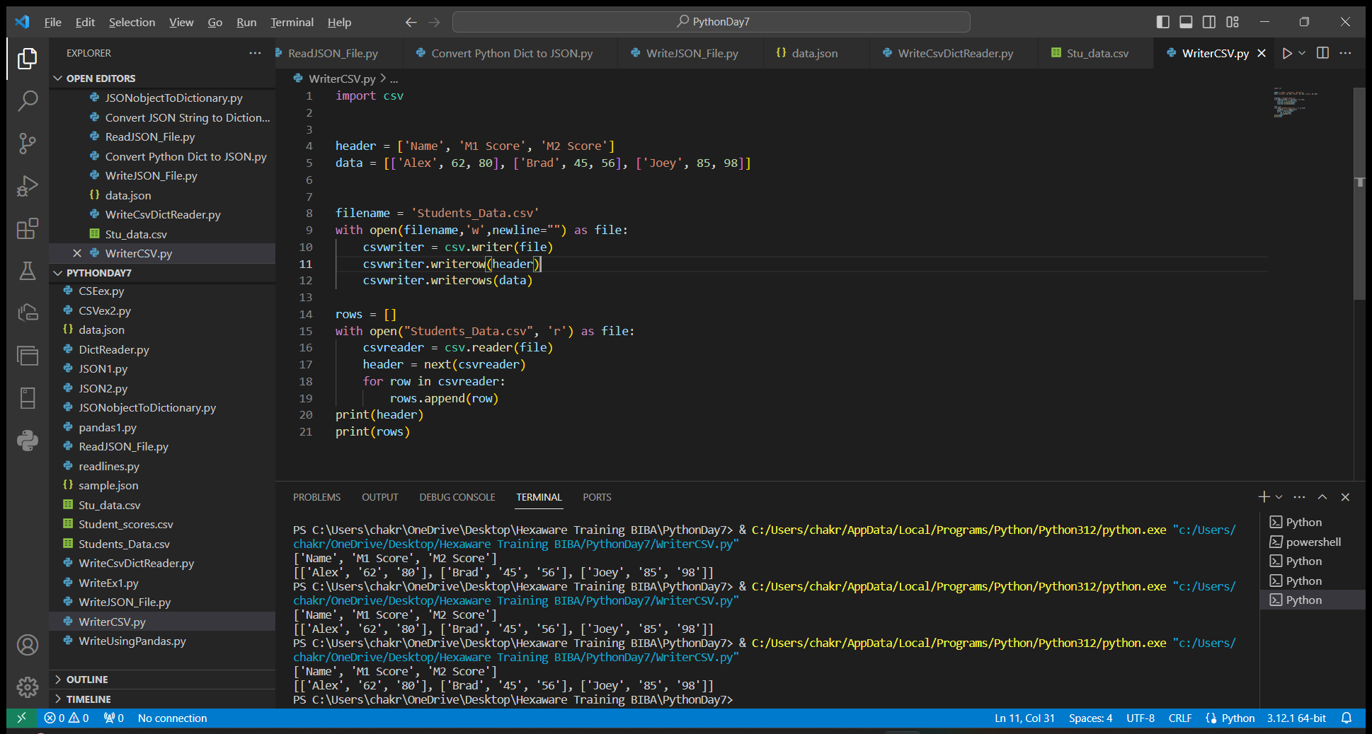

.writelines()

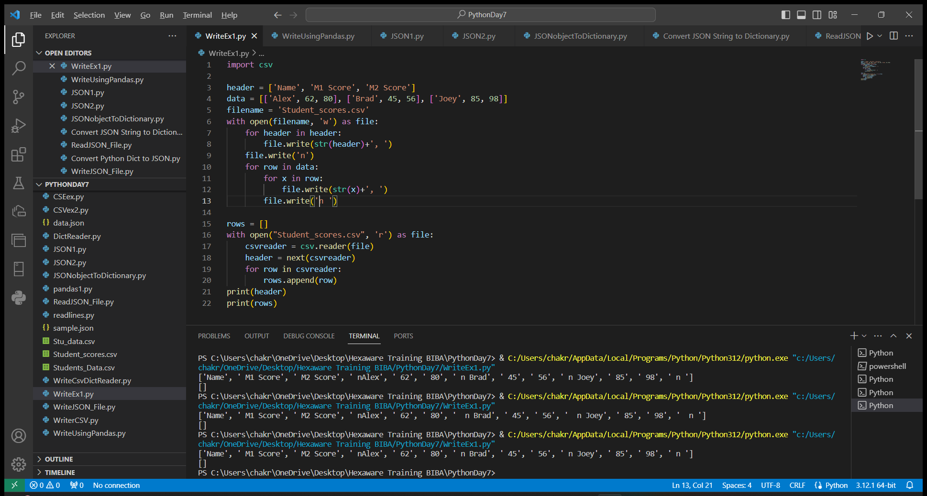

DictReader

The dict() method is used to create dictionary object from a set or iterables of keys and values.

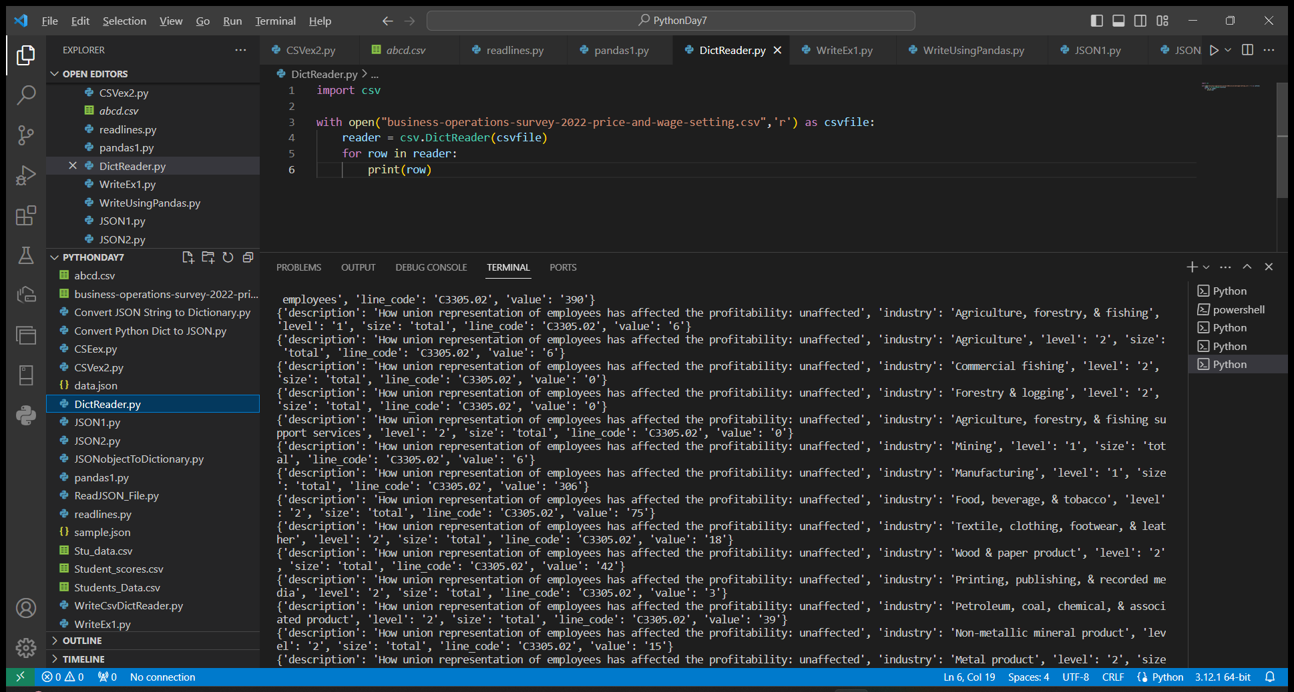

Pandas

Pandas is a library in python.

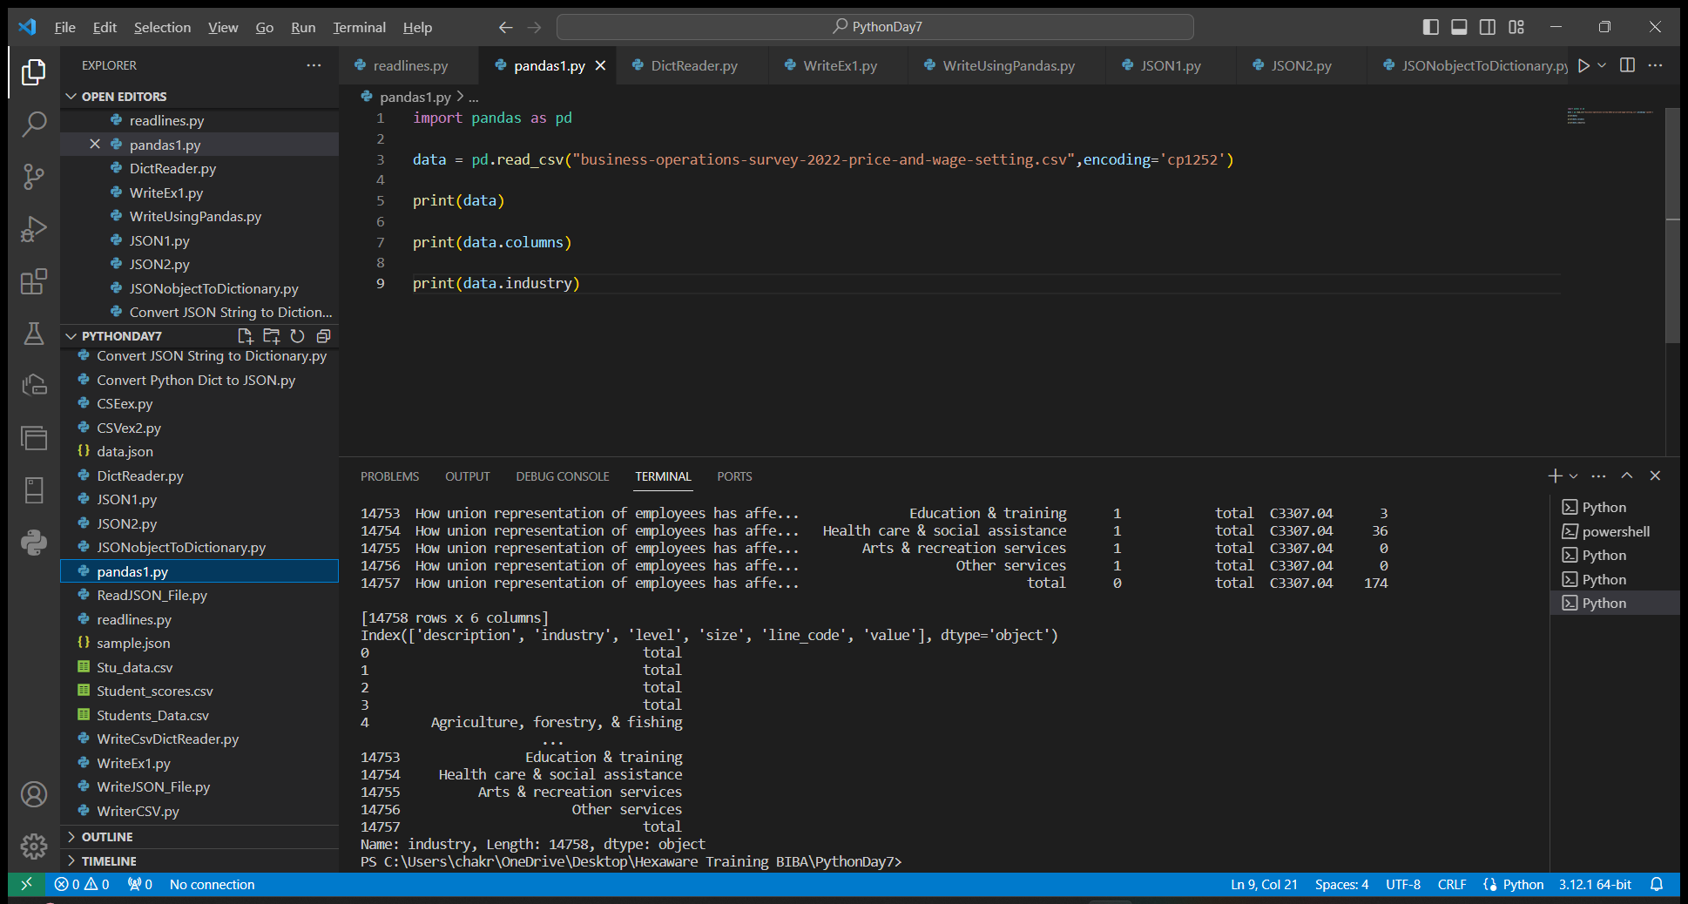

Writing using pandas

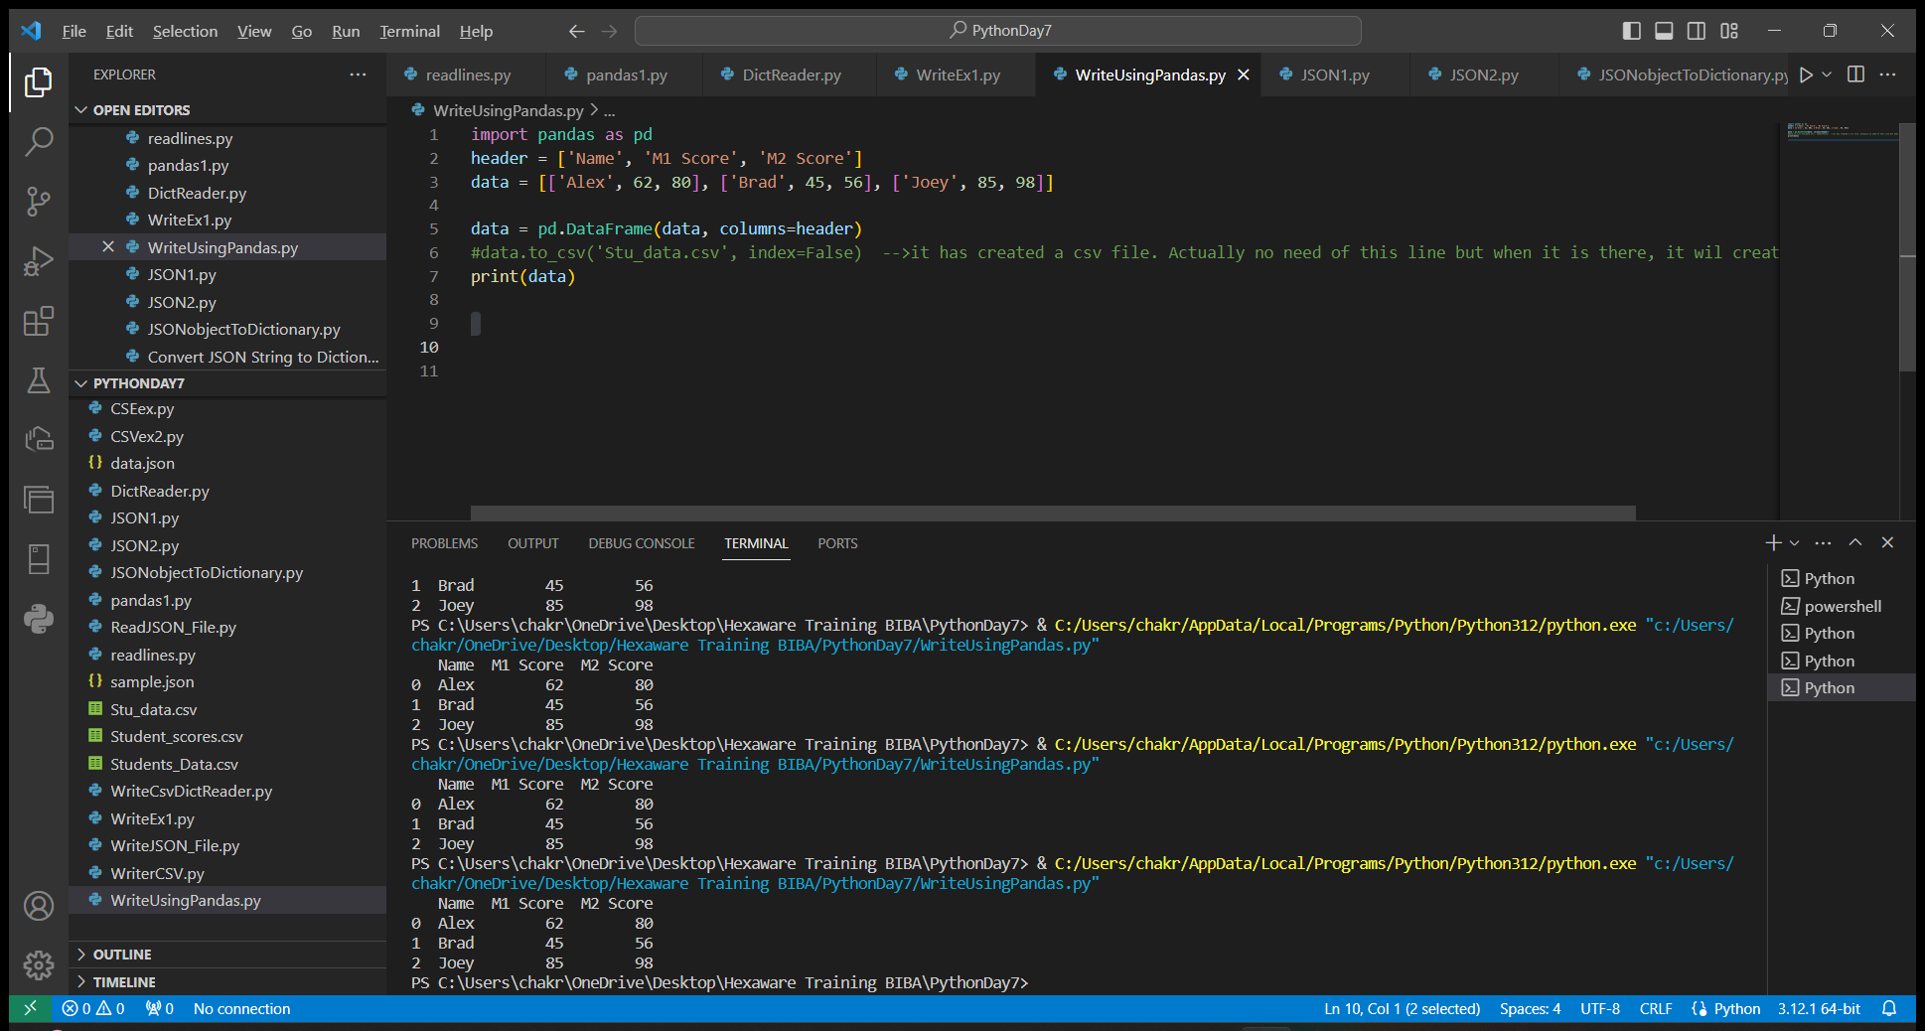

JSON(JavaScript Object Notation)

JSON is an open standard file format and data interchange format that uses human-readable text t store and transmit data objects consisting of attribute value pairs and arrays.

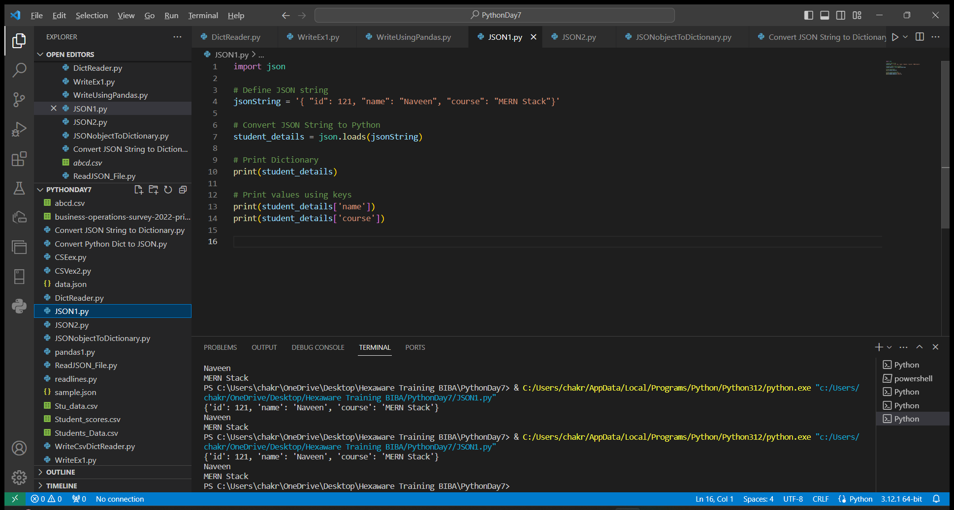

\

Taking external JSON file as an input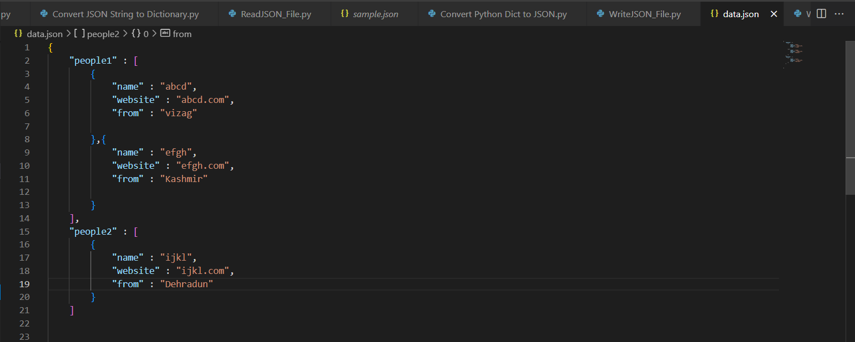

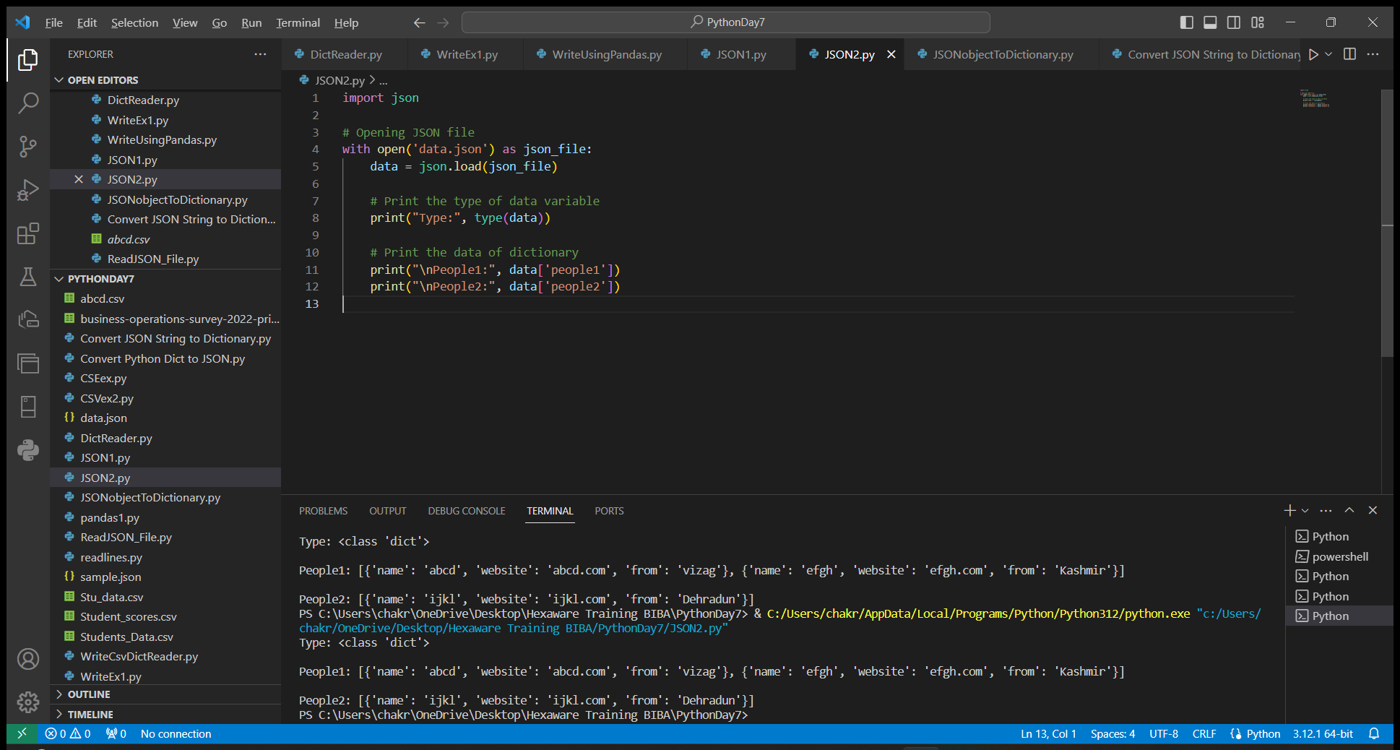

Read JSON file

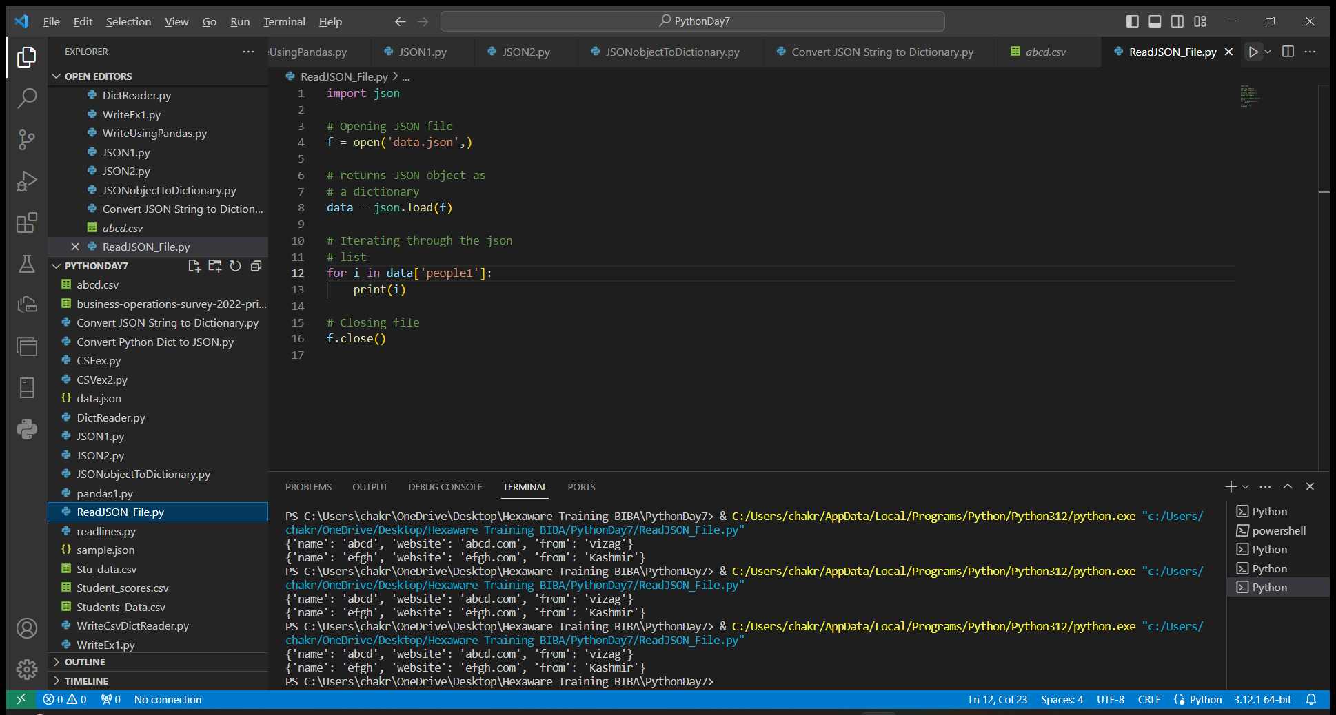

Write JSON file

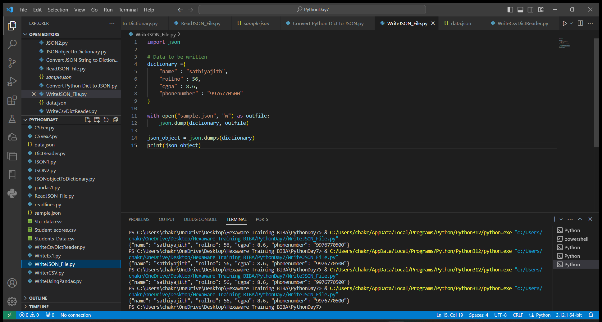

Convert Python Dictionary to JSON

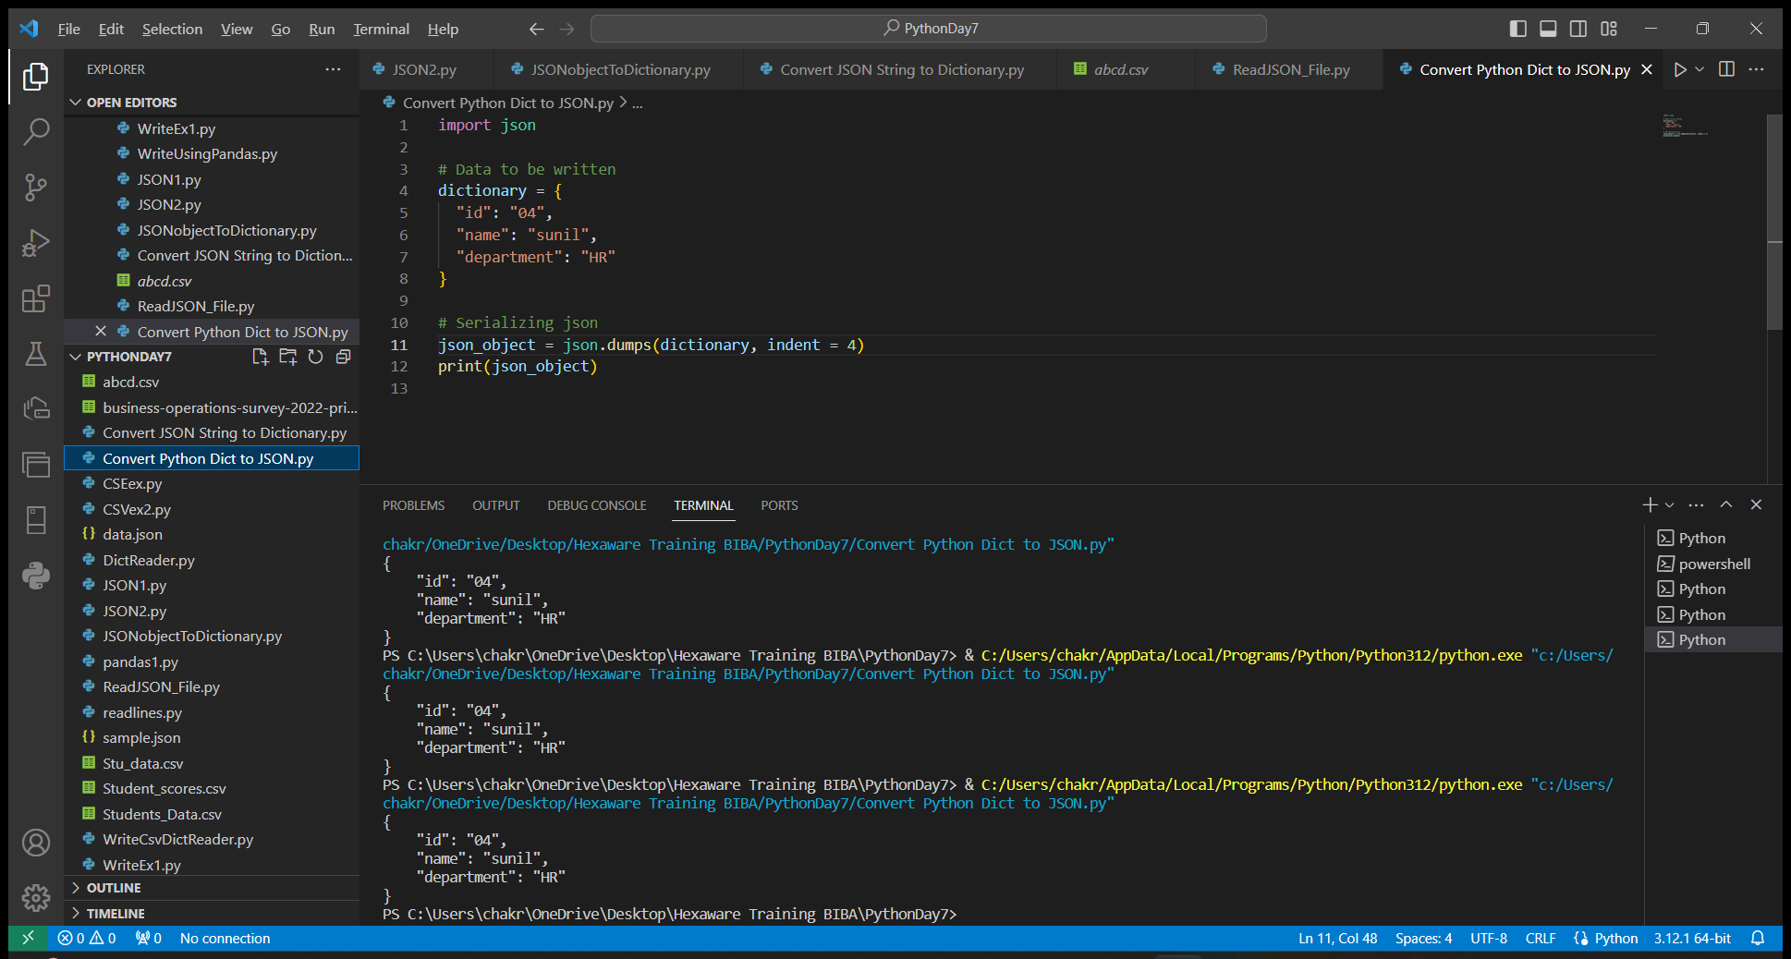

Convert JSON string to python dictionary

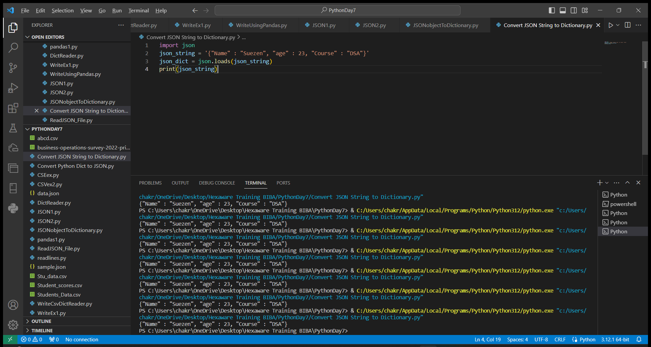

JSON object to dictionary

